# Export your AD Certificate and private key

## *Follow the steps below to export your Certificate and Private Key.*

# Goto **“C:\Openvpn”** directory then right click on **“**[**openvpn_cert.ps1**](https://drive.google.com/a/gslab.com/file/d/0BwEsFoHX046VdEdQVXRiOG05SG8/view?usp=sharing)**”** then click on **“Run with PowerShell”**.

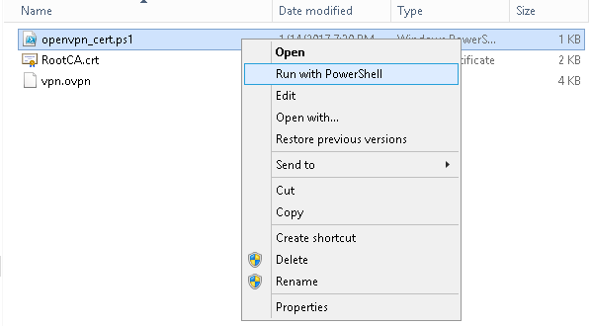

# PowerShell will be open then enter **gsLab123** everytime.

# 

# Goto **C:\Users\<Username>** there will be two files **<username>.crt** and **<username>.key** copy them to your OpenVpn config folder and also copy **vpn.ovpn** and **RootCA.crt** files from **C:\openvpn** to OpenVpn config folder.

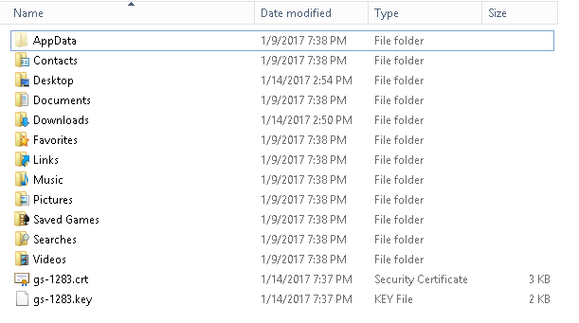

# Note:-

# 

# 1] Before connecting to OpenVpn Make changes in vpn.ovpn file to use your cert and key.

# 2] While connecting to openvpn it will ask for creds, enter your ad2Lab.com creds.